No Odd Perfect Numbers Exist

Zengyong LIANG
March 18, 2022
Abstract: The existence of odd perfect numbers is a well- known problem in number theory . This paper proved that no prefect number exist in the natural numbers .
Key words: perfect number; odd perfect number; combination; function
CLC number: O156. 1
1 Introduction
A perfect number is a number n such that _(n) = 2n. In other words a number is perfect number if it is the sum of its divisors other than itself . We only known a few of even perfect numbers[1][2][3] . It seems probable that there are no odd perfect numbers , bat this has not been proved. It is unknown whether there are any odd perfect numbers, though various results have been obtained. Carl Pomerance has presented a heuristic argument which suggests that no odd perfect numbers exist[5]
Any odd perfect number N must satisfy the following conditions:
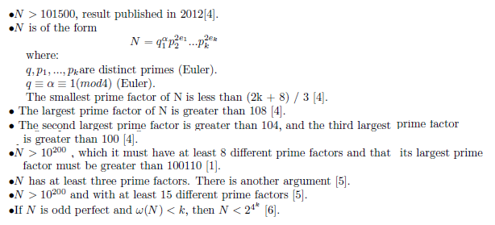
1.1 The Function _(N)
Definition: Function _(n) is the sum of combination of its divisors [1] .
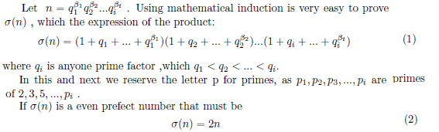
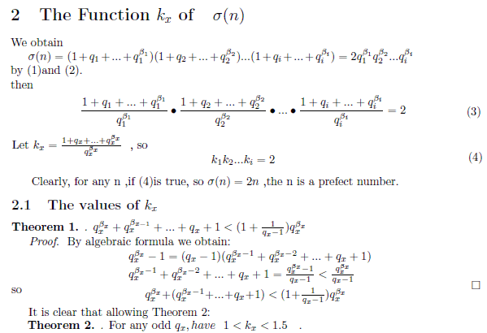
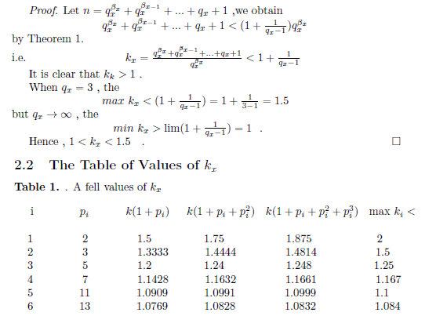
This shows that k is a monotone decreasing function with qx, when qx is larger, the smaller the kx. In contrast, when k is constant, it is monotonous litres of function with _x;when _x is the larger, the larger the k_{x.}
